**NAME – Manas Joshi**

**COURSE- BSC IT**

**STUDENT ID – 20051104**

**SUBJECT: OPERATING SYSTEM**

QUE1-

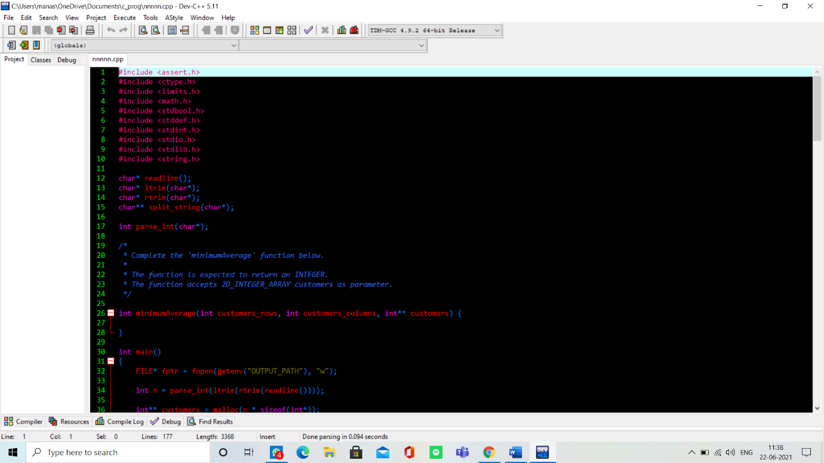

Que 2



